**DAILY ONLINE ACTIVITIES SUMMARY**

|  |  |  |  |  |  |  |  |  |
| --- | --- | --- | --- | --- | --- | --- | --- | --- |
| **Date:** | **15/06/2020** | | | | | **Name:** | **SUJANA** | |
| **Sem & Sec** | **IV sem & B section** | | | | | **USN:** | **4AL18CS089** | |
| **Online Test Summary** | | | | | | | | |
| **Subject** | | **-** | | | | | | |
| **Max. Marks** | | **30** | | **Score** | | | **-** | |
| **Certification Course Summary** | | | | | | | | |
| **Course** | **Introduction to Ethical Hacking** | | | | | | | |
| **Certificate Provider** | | | **Greatlearning academy** | | **Duration** | | | **4.0 hours** |
| **Coding Challenges** | | | | | | | | |
| **Problem Statement1:** Write a Java Program to find if string is K-Palindrome or not.  **Problem Statement2:** Write a C Program to perform the following operations on Triply Linked.  **Problem Statement3:** Write a C Program to implement the Binary Reversal. | | | | | | | | |
| **Status: Executed** | | | | | | | | |
| **Uploaded the report in Github** | | | | | **YES** | | | |
| **If yes Repository name** | | | | | **Online-coding** | | | |
| **Uploaded the report in slack** | | | | | **YES** | | | |

Online Test Summary: No internals conducted today.

Online Certification Course Summary: Today I have learnt about what exactly is ethical hacking and also about computer Security threats. This is the last session of Ethical hacking course.

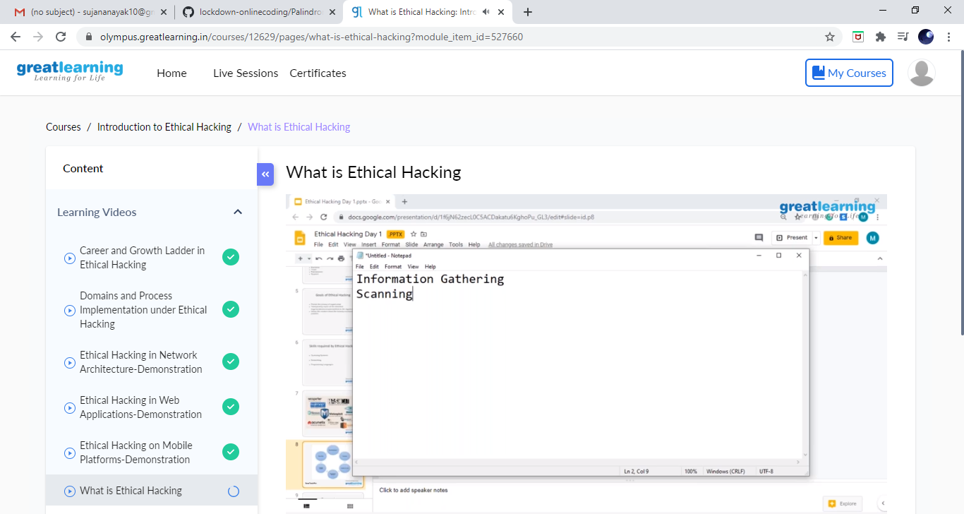

Online Coding Summary: **Today I had received one program from prof. Shilpa CSE Dept. and prof.Venkatesh CSE Dept. The program is mentioned above in the coding challenges(pg.01). I have also uploaded it to my Github repository.**

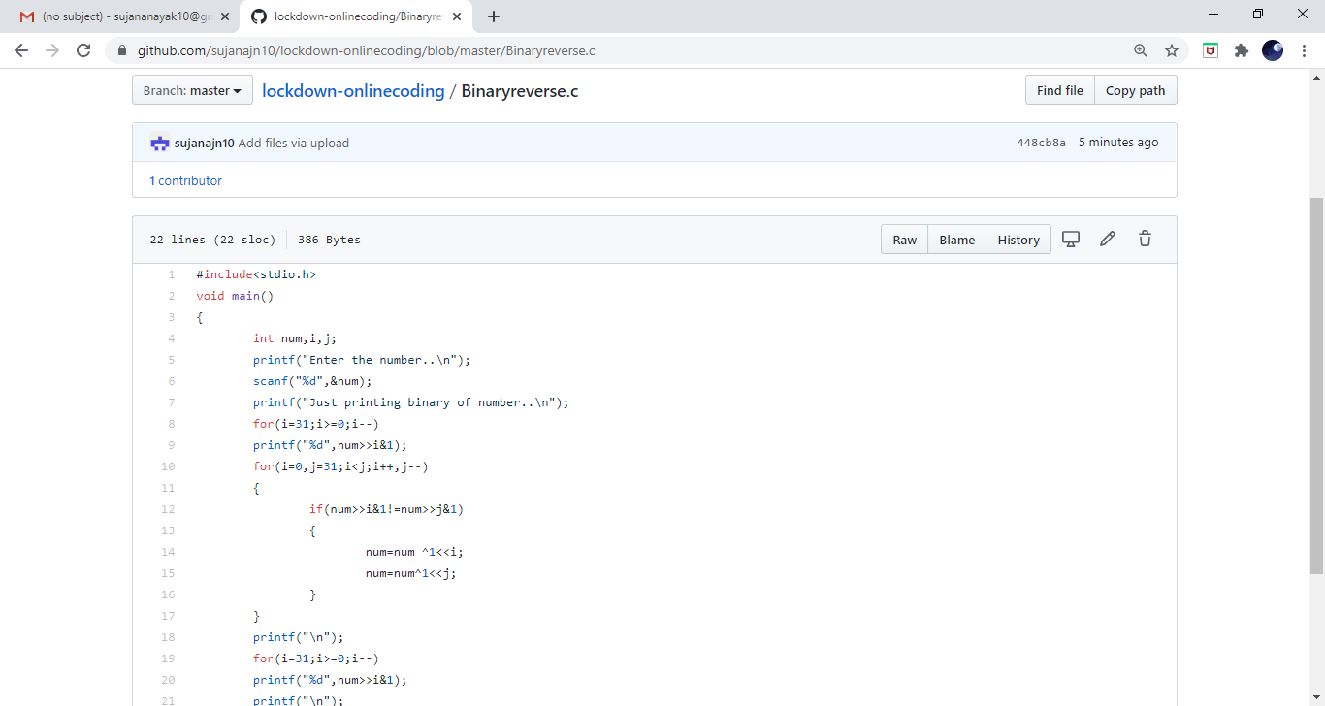

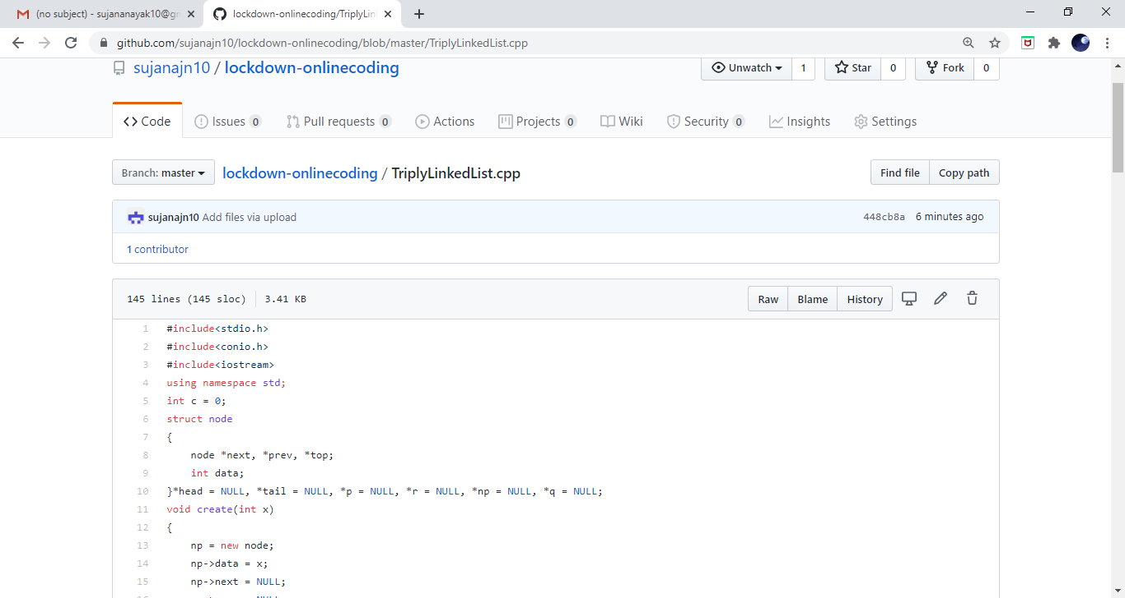

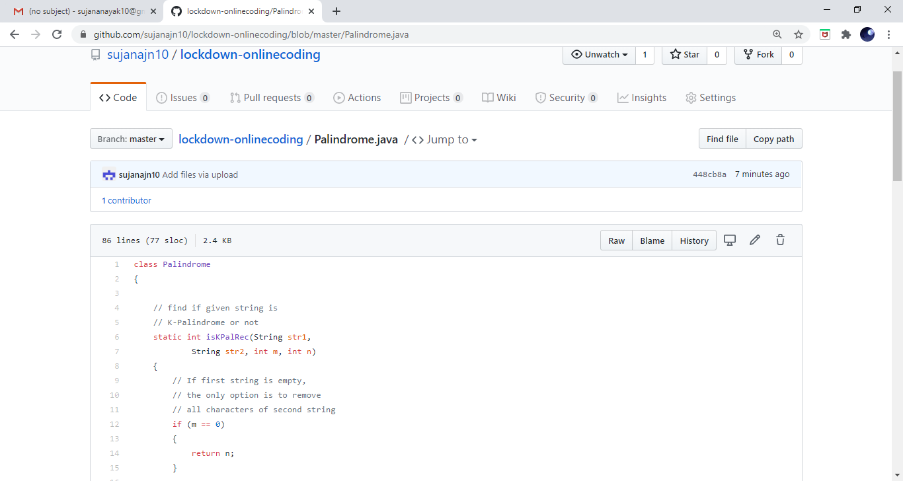

**These are the snap shot of my Github repository** were I have uploaded the code. File name is binaryreverse.c, triplylinkedlist.cpp and Palindrome.java